October 12th 2021

Dear parents

It is with regret that our school after school club provision will come to an end on Friday 22nd October. This is due to it not being financially viable for school, as our budget is not able to subsidise a provision that continues to be under subscribed.
Thank you to Mrs Karsli and Miss Malone for their hard work this half term and the families who have accessed our provision, but unfortunately the numbers remain too low to sustain.
The Governing Body may consider after school provision again at some point in the future, but until then, thank you to the families that supported the provision this half term.

Kind regards

Kind regards
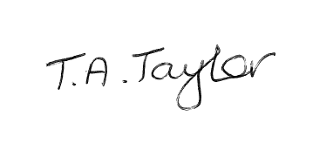
Tracey Taylor
Headteacher
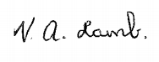
Ms V Lamb
Chair of Governor

