LGBTQ+ month
 | Resources
EYFS | Stonewall poster – Different Families, Same Love  Story – and Tango makes three | 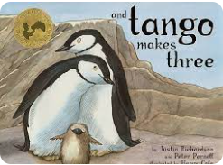
KS 1 | Stonewall poster – Different Families, Same Love.
KS1 & 2 | Stonewall lesson resources – Robert Cowell  Discussions at an age appropriate level depending on age.  Please see Stonewall attachment

